Ques.3) Basic Device Configuration Add a Router, Switch, and PCs to the workspace. Assign IP addresses to PCs. Configure a Router's interfaces with IP addresses. Set hostnames for the devices.

Ans.) Step 1: Add Devices to Workspace

Add a Router, Switch, and two PCs to the workspace from the device toolbar.

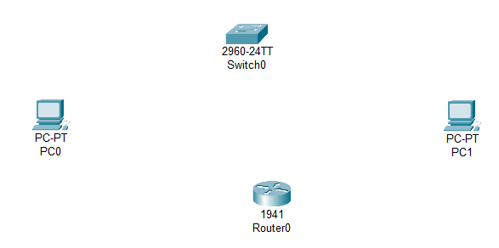

Step 2: Connect Devices with Cables

Use Copper Straight-Through cables to connect:  
• PC0 to Switch  
• PC1 to Switch  
• Switch to Router

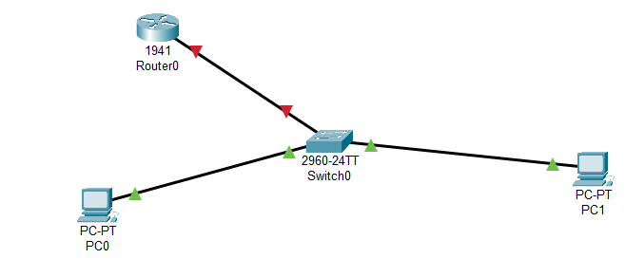

Step 3: Assign IP Addresses to PCs

Click on each PC > Desktop > IP Configuration:  
• PC0: IP Address: 192.168.1.10  
 Subnet Mask: 255.255.255.0

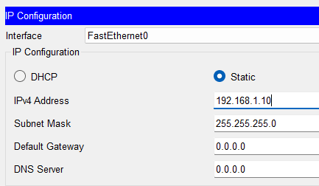

• PC1: IP Address: 192.168.1.11  
 Subnet Mask: 255.255.255.0

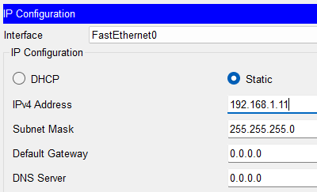

Step 4: Configure Router Interface

• Click Router > CLI and enter:  
enable configure terminal hostname R1 interface gig0/0  
ip address 192.168.1.1 255.255.255.0

no shutdown  
exit

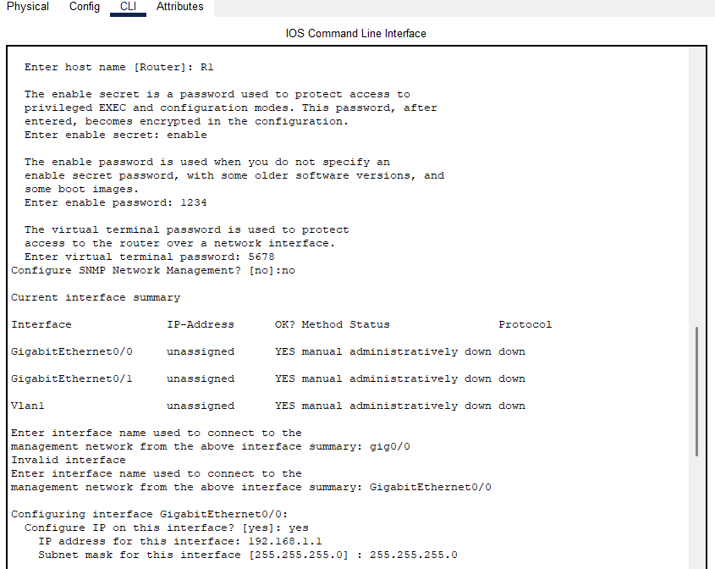

Step 5: Set Hostnames

• Router: Already set above as R1  
• Switch: CLI > enable > configure terminal > hostname S1

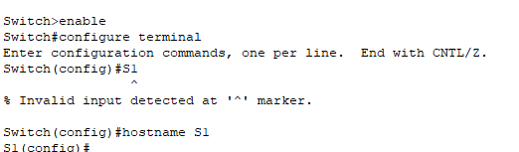

  
• PCs: Go to Config tab > Settings > Change Display Name

• PC0 change to PC FIRST

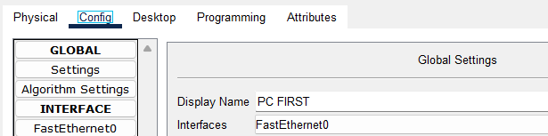

• PC1 change to PC SECOND

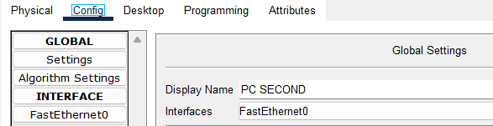

Ques.4) Configuring VLANs. Add a switch and multiple PCs.Create VLANs and assign ports.

Configure trunk ports between switches.Verify VLANs with show vlan brief.

Ans.) Step 1: Add Devices to Workspace

• Add at least one Switch (e.g., Switch0) and multiple PCs (e.g., PC0, PC1, PC2, PC3) to the workspace.

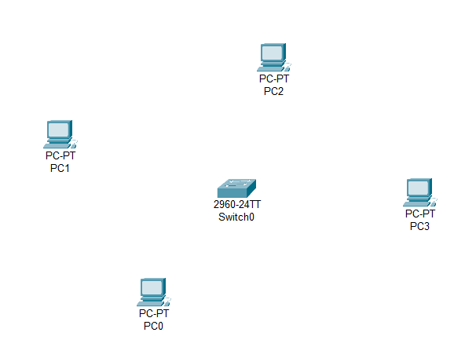

Step 2: Connect PCs to the Switch

• Use Copper Straight-Through cables to connect each PC to a different FastEthernet port on the switch (e.g., Fa0/1 to Fa0/4).

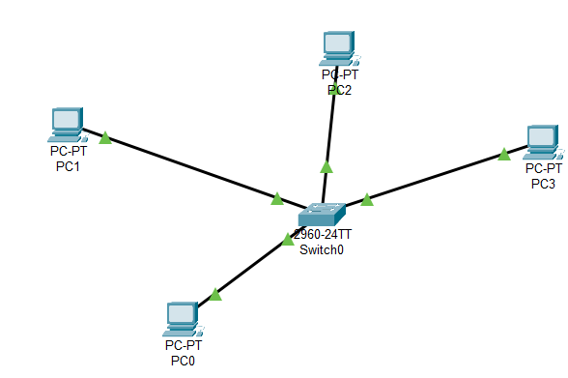

Step 3: Create VLANs

• Click on the switch > CLI and enter:  
enable configure terminal vlan 10 name HR  
exit  
vlan 20 name IT  
exit

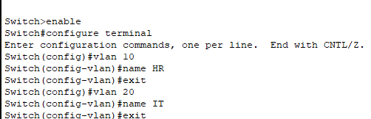

Step 4: Assign VLANs to Switch Ports

• Assign ports to VLANs: interface range fa0/1 – 2 switchport mode access switchport access vlan 10  
exit  
interface range fa0/3 – 4 switchport mode access switchport access vlan 20  
exit

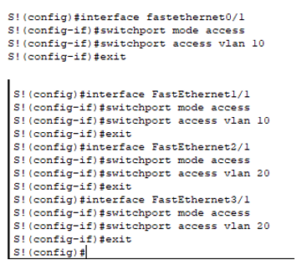

Step 5: Save Configure

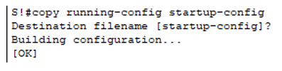

Step 6: Verify VLAN Configuration

• Use the following command to check VLANs:  
show vlan brief

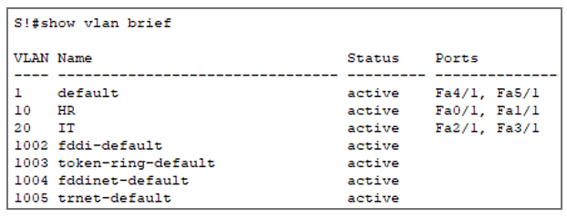

Ques.5) Configuring Static Routing Use two routers and connect them with a network. Assign IP addresses and subnet masks. Configure static routes using the ip route command. Test connectivity between devices using ping.

Ans.) Step 1: Network Setup

• Use two routers (Router0 and Router1) and connect them via a crossover cable. Connect a PC to each router using a straight-through cable.

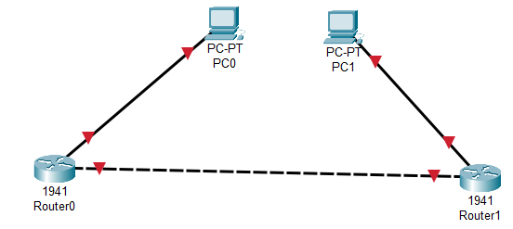

Step 2: IP Addressing Scheme

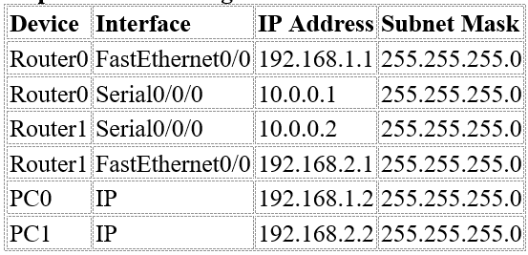

Step 3: Assign IP to PC0 & PC1

→ Click PC0 → Desktop → IP Configuration

• IP Address: 192.168.1.2

• Subnet Mask: 255.255.255.0

• Default Gateway: 192.168.1.1

→ Click PC1 → Desktop → IP Configuration

• IP Address: 192.168.2.2

• Subnet Mask: 255.255.255.0

• Default Gateway: 192.168.2.1

Step 4: Configure Router0

• Go to Router0 CLI:

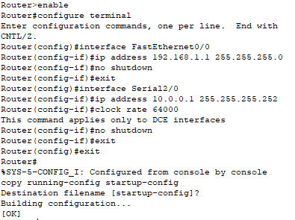



Step 5: Configure Router1

• Go to Router1 CLI:

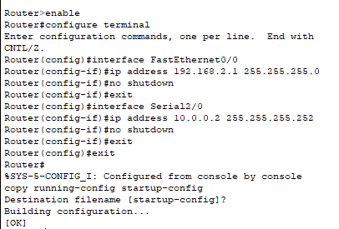

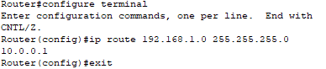

Step 6: Test Connectivity

• Go to PC0 → Command Prompt

• Go to PC1 → Command Prompt

Ques.6) Configuring dynamic routing. Use multiple routers and assign IP addresses and configure RIP/OSPF

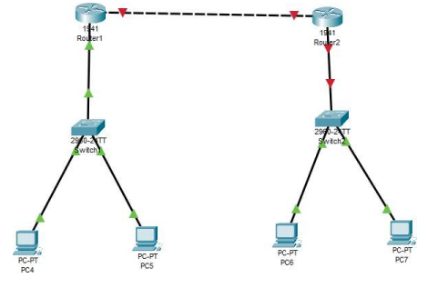

Basic Setup Before Dynamic Routing

Assume:

• 3 Routers (R1, R2, R3)

• PCs connected to each router

• Use serial or fast Ethernet connections between routers

• Use IP addresses in different subnets

1. Configuring RIP (Routing Information Protocol)

Step 1: Assign IP Addresses to Interfaces

For each router (example for R1):

Router> enable

Router# configure terminal

Router(config)# interface FastEthernet0/0

Router(config-if)# ip address 192.168.1.1 255.255.255.0

Router(config-if)# no shutdown

Router(config-if)# exit

Router(config)# interface Serial0/0/0

Router(config-if)# ip address 10.0.0.1 255.255.255.0

Router(config-if)# no shutdown

Router(config-if)# exit

(Repeat for R2 and R3 with different IPs)

Step 2: Enable RIP Routing Protocol

Router(config)# router rip

Router(config-router)# version 2

Router(config-router)# no auto-summary

Router(config-router)# network 192.168.1.0

Router(config-router)# network 10.0.0.0

Router(config-router)# exit

(Do the same for R2, R3 with their networks)

Example RIP Networks:

• R1:

o 192.168.1.0

o 10.0.0.0

• R2:

o 192.168.2.0

o 10.0.0.0

o 10.0.1.0

• R3:

o 192.168.3.0

o 10.0.1.0

1. Configuring OSPF (Open Shortest Path First)

Step 1: Assign IPs to Interfaces (Same as RIP) Step 2: Enable OSPF

Router(config)# router ospf 1

Router(config-router)# network 192.168.1.0 0.0.0.255 area 0

Router(config-router)# network 10.0.0.0 0.0.0.255 area 0

Router(config-router)# exit

• Replace network addresses according to your topology.

• The wildcard mask 0.0.0.255 = subnet mask 255.255.255.0

Test Connectivity

On each PC:

ping If routing is correctly configured, pings should succed.